UNITED WAY 211 CHECKLIST
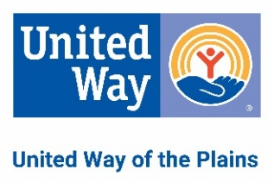
It’s EASY to list your agency in the 211 database!
Please use this checklist when sending in your forms.

- Complete the “Agency” form (download from unitedwayplains.org/211). Please fill in every field – if it is not applicable to your agency please put N/A.
- Complete the “Program” form (download at untiedwayplains.org/211). Copy the “Program” form as necessary depending on the number of programs your agency sponsors. Complete one form for each program. This form looks very similar to the “Agency” form, but it has additional important information. (It's important to know the difference between agencies and programs, because sometimes both will have the same name! A program is a specific service - such as a work-training program for adults - whereas an agency is the organization that hosts the program.)
- Please ensure that you accurately list all services provided by the program, as that is what our referrals will be based on. For example: A food pantry program would list services such as one weeks worth of food, hygiene items, diapers when available, etc. and an emergency financial assistance program would list services such as rent, utility, funeral assistance, etc.
- Please enclose a copy of your agency’s 501(c) status (if applicable).

Email to: hpierce@unitedwayplains.org

Mail to: United Way 211 of Kansas
245 N. Water St.
Wichita, KS 67202

